Contents

Prostate Delineation- Documentation 2

GUI Usage 3

Settings 5

Display 5

Process 5

Export Stats 5

Settings 6

Clip Limit 6

Grid Size 6

Blur Size 6

Threshold 6

Block Size 6

Min Area 6

Max Area 6

Reset Settings 6

Crop Image 7

Select ROI 8

Process 10

# Prostate Delineation - Documentation

This software is for the automated delineation of the prostate from Magnetic Resonance Imaging (MRI), to be used by researchers. This software is open-source and can be found on github for download from the AIEMMU page. it has been designed to be modular and usable with other projects and allowing for new code to be added easily to the project.

This software can read Dicom images and outputs the contours as text files. There are plans to expand the software so it may be used for multiple slices from a dicom file or folder of slices. With the end goal to work with clinicians to make this more usable and friendly for medical staff and researchers.

This document will provide documentation and usage of the software.

# GUI Usage

This program allows users to load a single dicom image. To begin, press file and load dicom. This will prompt the user to select a video to track.

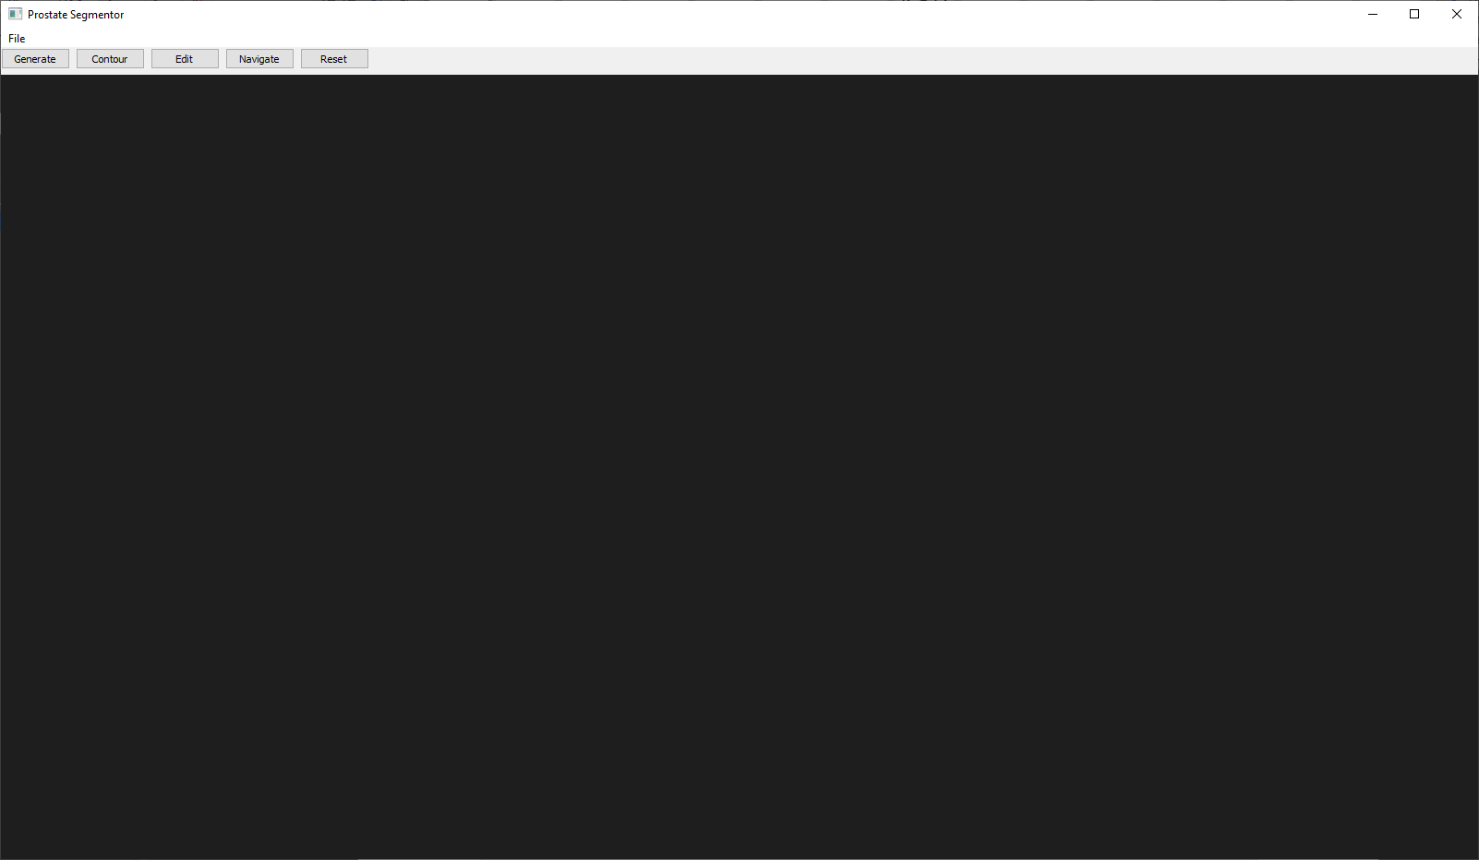

Once a Dicom has been the MR image will appear within the Graphical Interface.

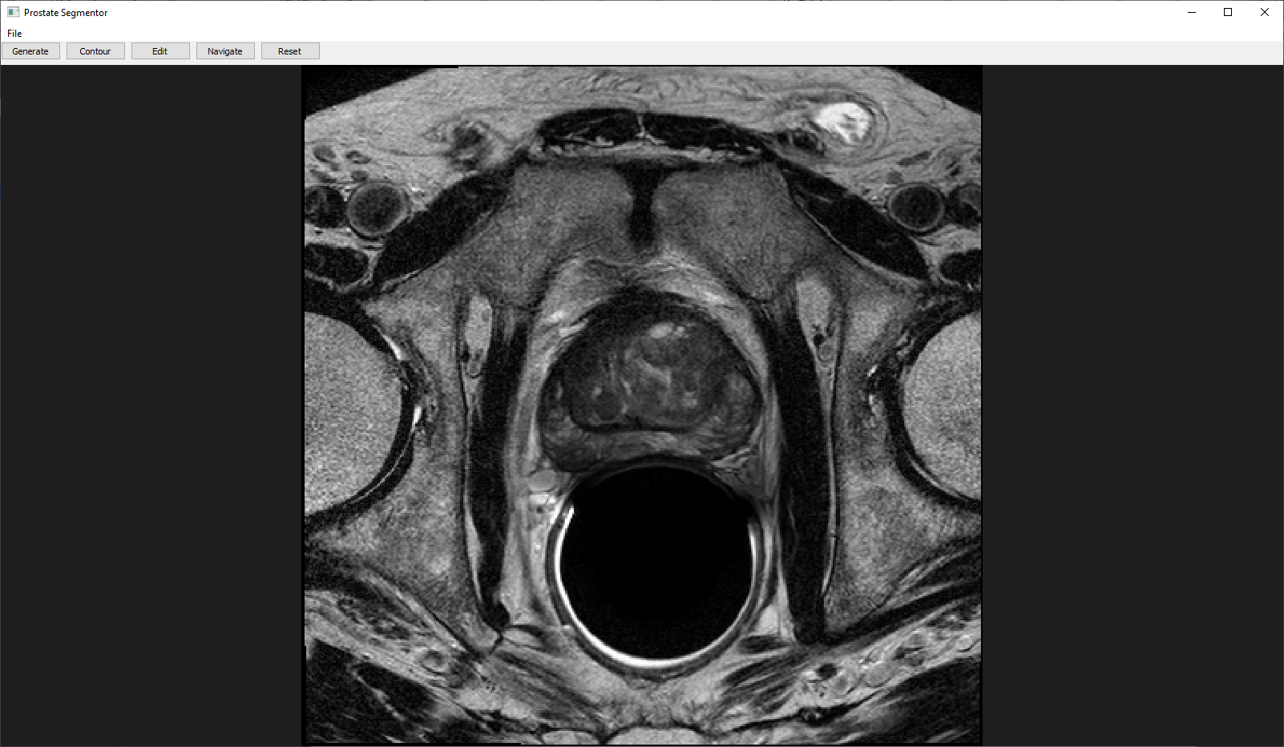

The interface has 5 buttons:

### Generate

This will button will generate a contour for the MRI, and produce a contour on the screen. The contour is fully editable for the user, and can be saved, with an output as a text file. This can be loaded into this software or loaded into their own software if they wish to use it.

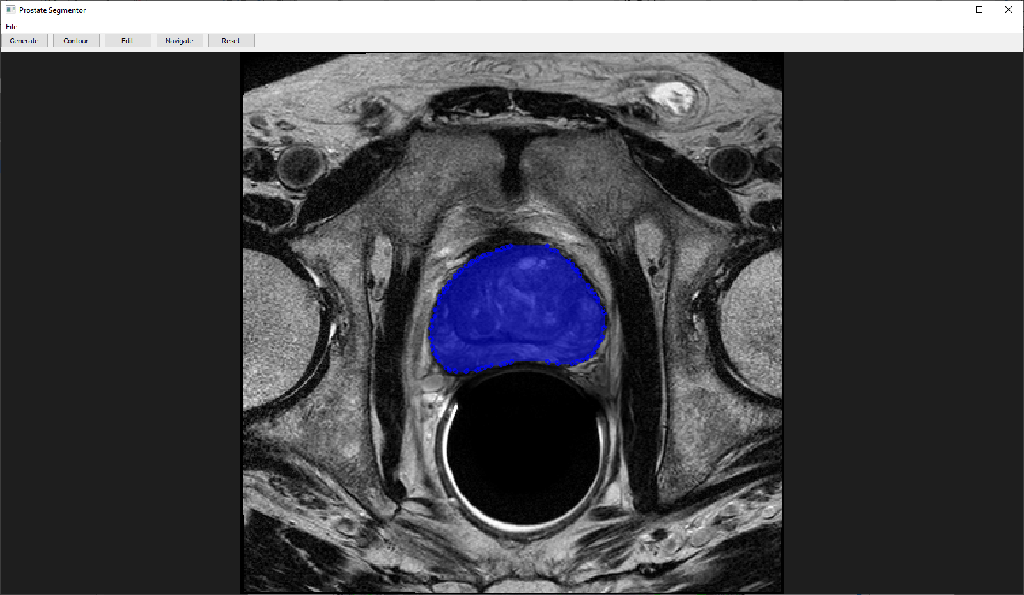

If the loaded dicom file is not an Axial slice, it will notify the user, and express that the output might not be as accurate as an Axial slice.

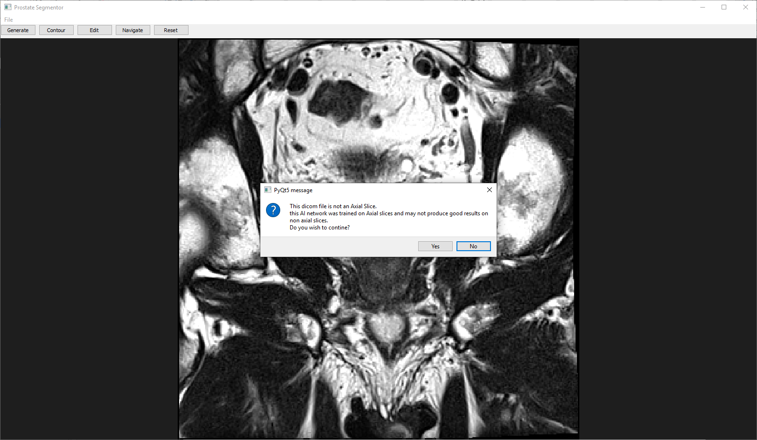

### Contour

This button will allow the user to create a contour on the image, and outline the prostate manually if the AI has not generated a good outline. By pressing the contour button and left mouse clicking on the image, it will create a contour.

Controls:

Left mouse button: Add a contour point

Right mouse Button: Remove last contour point to be added.

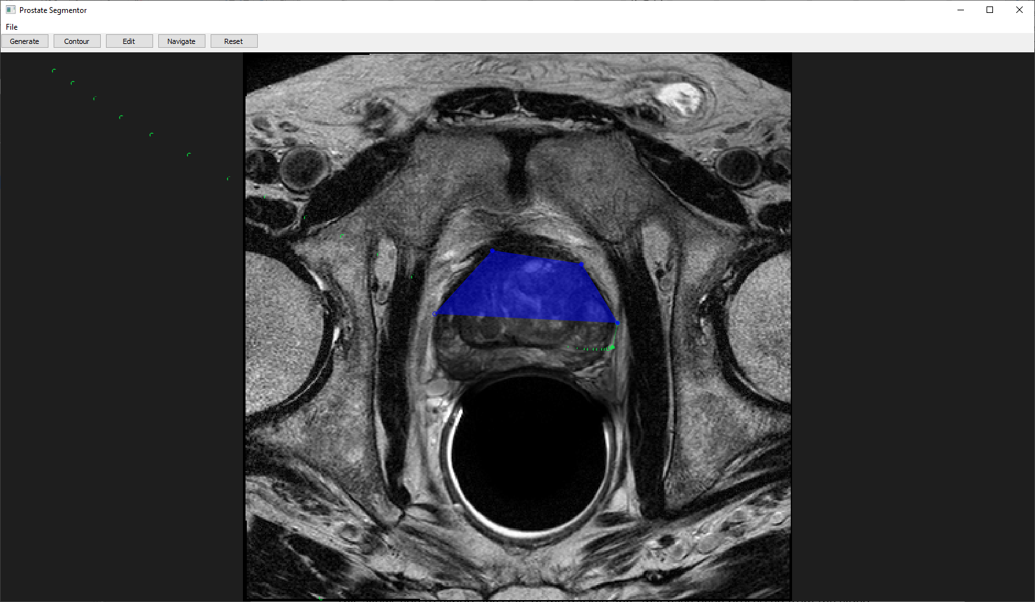

By pressing the right mouse button, it will remove the last point that was added to the contour.

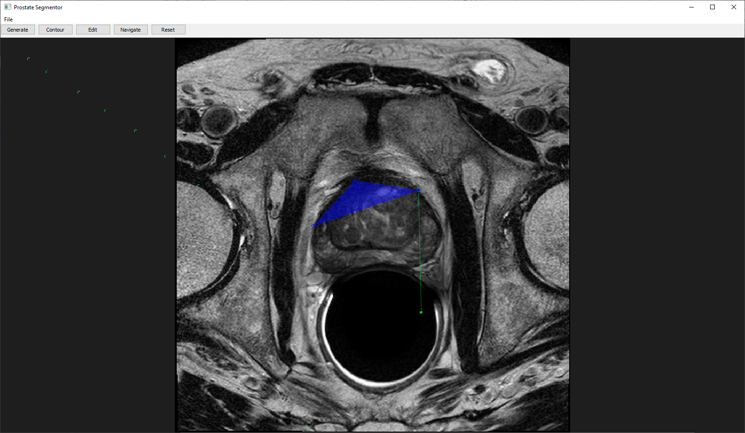

### Edit

With a contour is completed it can be edited by the user. This can include manipulating the points, removing points or adding points.

Controls:

Left mouse button over a control point: This allows the user to move a point.

Right mouse button over a control point: This will remove the control point.

Middle mouse button. This will add a new control point to the contour.

Adding a point.

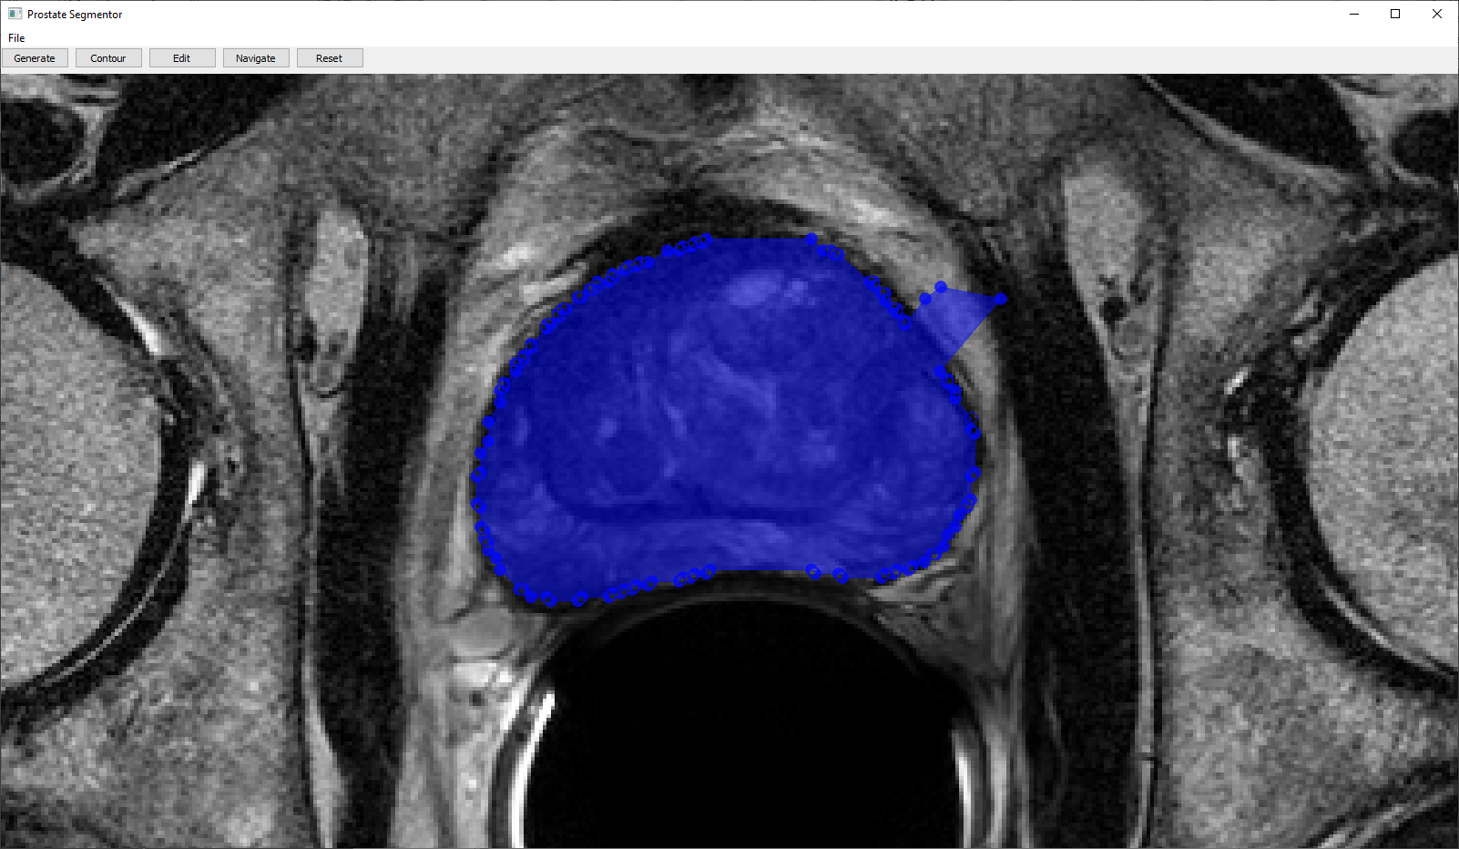

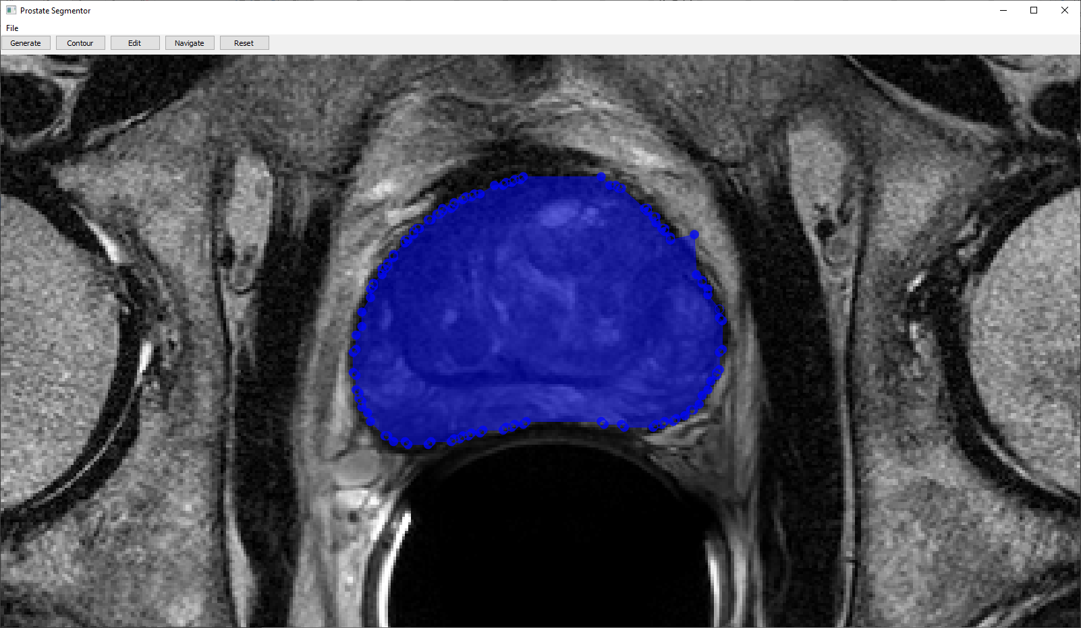

Removing a point.

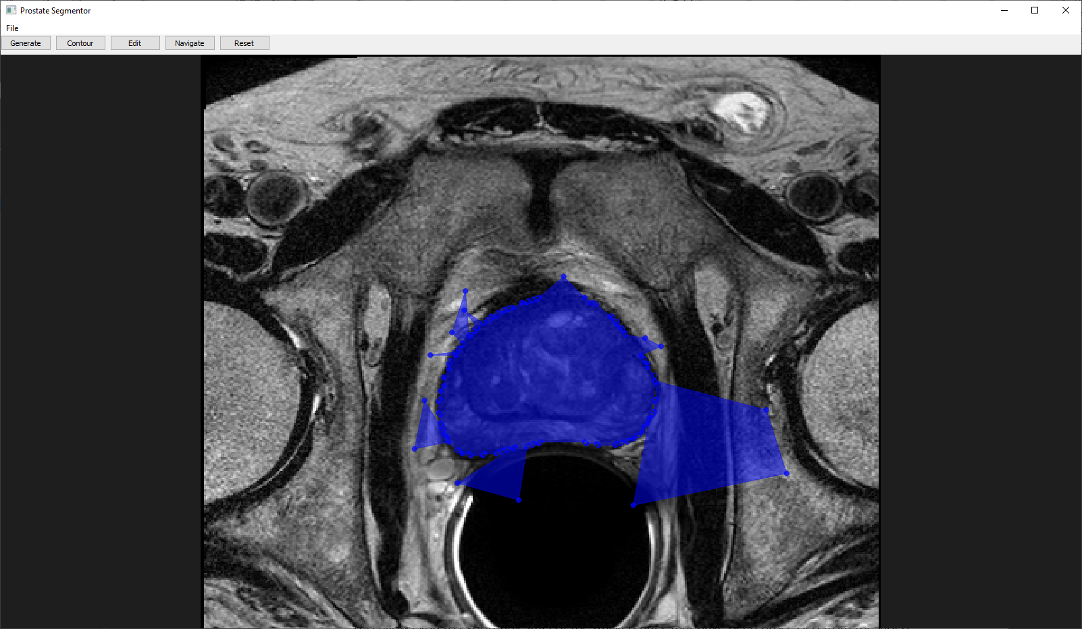

Adding new points to the contour.

Navigate

This will allow the user to pan and zoom into the dicom file, during editing or contouring the image.

Controls:

Left mouse button: By holding this button the user can pan around the image.

Middle Scroll button: By scrolling the user can zoom in.

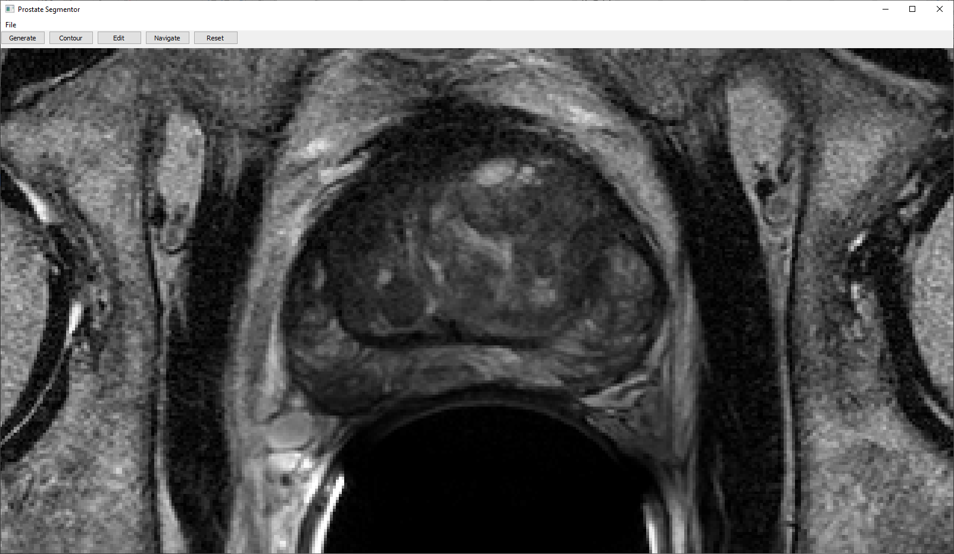 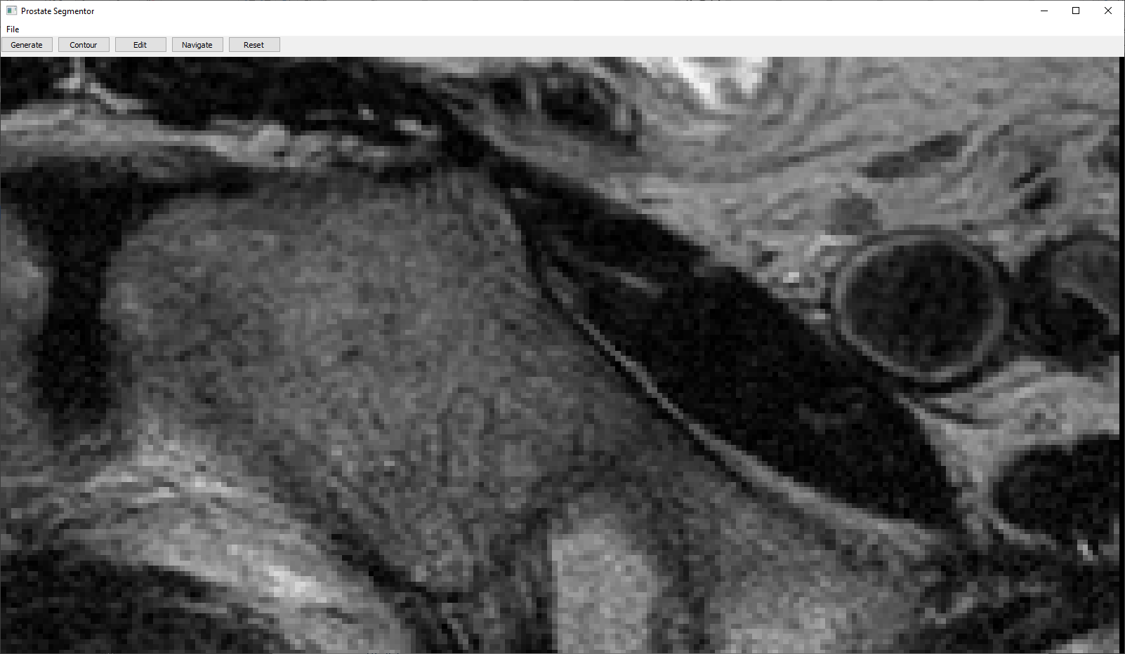

### Reset

This resets all of the contours and resets the view of the dicom file.

### Save contour

This allows you to export the contour that has been created by the user. It contains the points of the contour so it may be loaded into other software or back into this software.

### Load Contour

This allows the user to load in previously saved contours.